**Home Page Products**

**1.African Voilet:**

**African violets (Saintpaulia ionantha)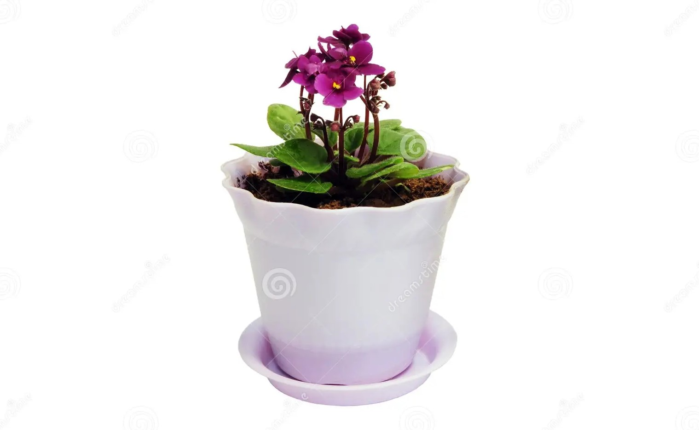 are low maintenance, easy to grow houseplants. They reliably bloom several times a year when cared for properly. Native to Eastern Africa, these popular houseplants are in the same family (Gesneriaceae) as gloxinia and primrose.** **These plants are of great importance in horticulture mainly used as indoor ornamental plants. The plants are the most widely grown of all house plants throughout the world. Although several species have ornamental value in the wild,**

# **2.House Potted:**

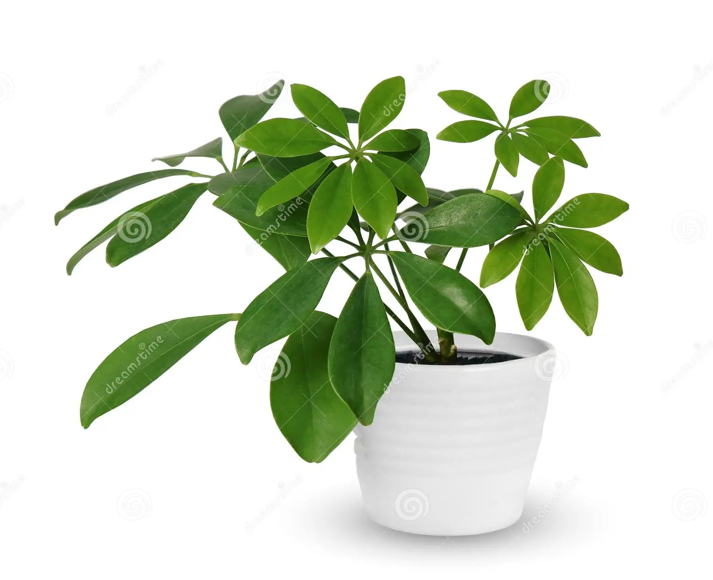**A houseplant, sometimes known as a pot plant, potted plant, or an indoor plant, is an ornamental plant that is grown indoors. The traditional indoor approach uses plant pots with drainage holes in the bottom that sit in a saucer to catch the excess water as it drains through the soil.** **Plastic and fiberglass pots don't need to be watered as frequently as clay. Other materials for houseplant containers include metal, basketry, treated or rot-resistant**

# **3.Pink Blossom:**

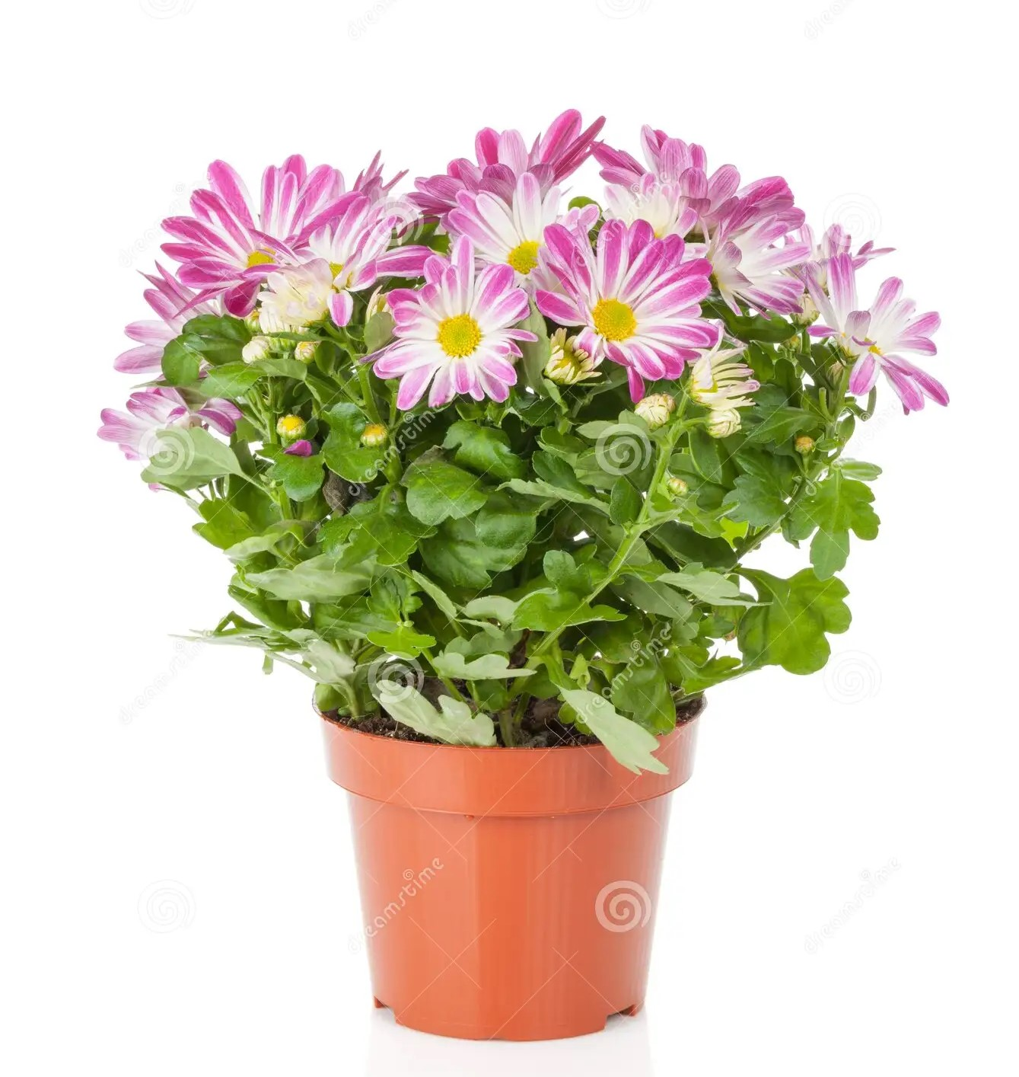**The flowering part of a plant or tree that will form the seeds or fruit is called a blossom and synonyms include bloom and flower. The noun can also refer to the state of such flowering. You shouldn't miss cherry blossom time in Washington, D.C.** **Blossoms are the blooms that grow profusely for a while in spring on stone fruit trees and other plants with a similar appearance. At specific times of year, flowering plants produce a protein known as Flowering Locus T in their leaves that induces flowering. Once this protein is made, it travels from the leaves to the shoot apex, a part of the plant where cells are undifferentiated, meaning they can either become leaves or flowers. Blossoms provide pollen to pollinators such as bees, and initiate cross-pollination necessary for the trees to reproduce by producing fruit. Blossom trees have a tendency to lose their flower petals in wind-blown cascades, often covering the surrounding ground in petals.**

**4.Decotated Fittonia:**

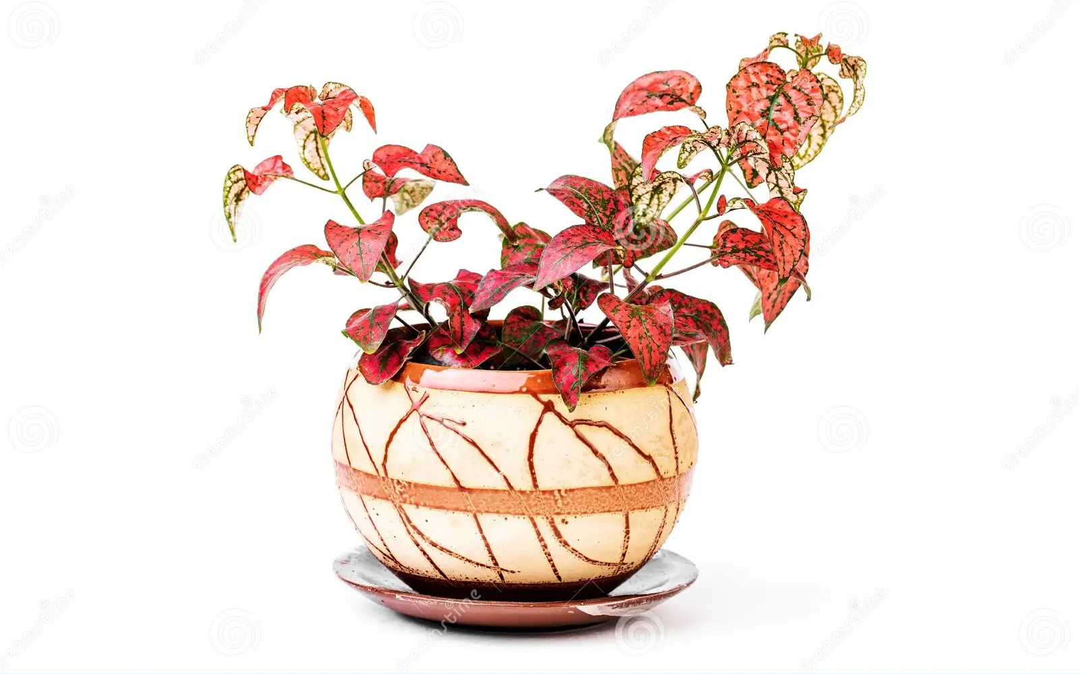**The Fittonia Genus is named after Sarah Fitton and Elizabeth Fitton, botanists living in the 19th century. Their work helped make botany, as a field of scientific study, more popular for women.** **They are spreading evergreen perennials growing 10–15 cm (4–6 in) tall. They bear lush green leaves with accented veins of white to deep pink and have a short fuzz covering their stems. Small buds may appear after a time where the stem splits into leaves. Normally grown as a potted houseplant, nerve plant (Fittonia spp.) is a spreading evergreen perennial with delicately veined, deep-green, ovate leaves. Although the most popular vein color is silvery-white, you can also readily find varieties with veins in red, pink, white, and green. Nerve plants may help to reduce stress, improve air quality, boost productivity, and remove harmful chemicals from the air. Nerve plants are also compact, making adding them to your home easy.**

# **5.Glory of the Green:**

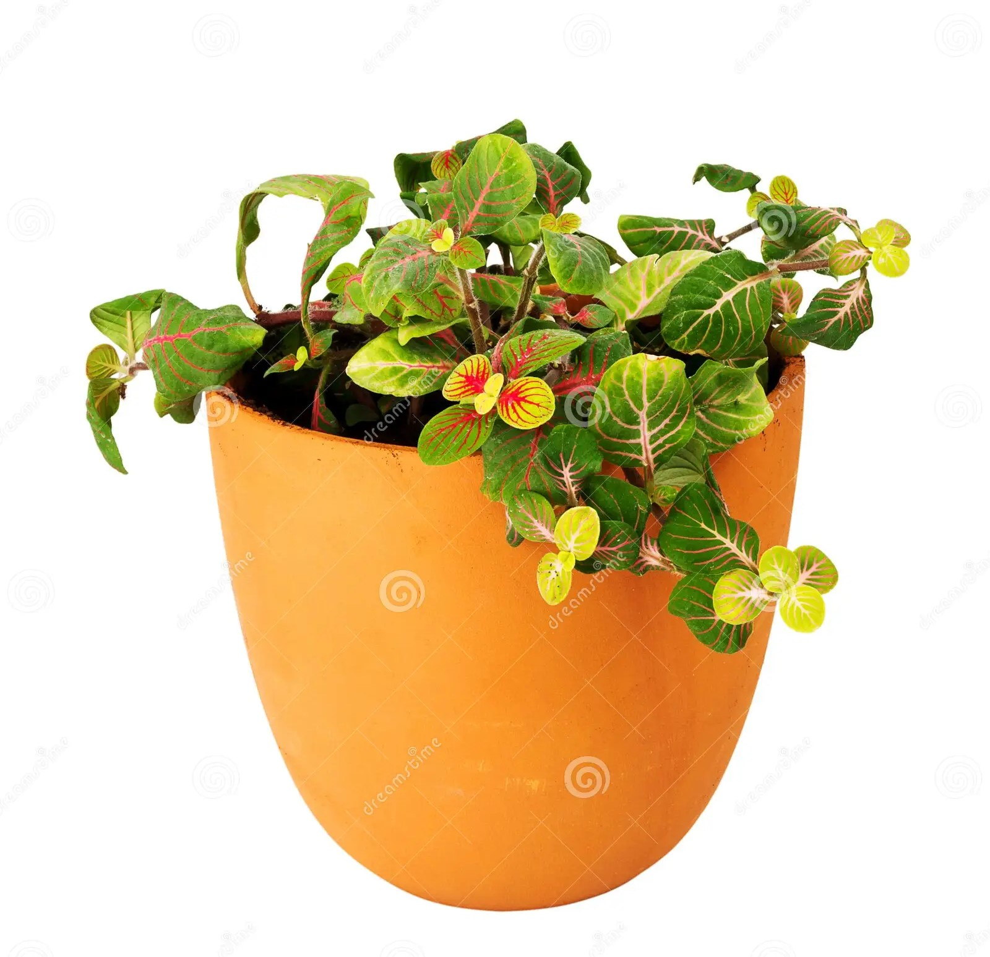**Some green flowers are by nature showstoppers, like heavenly 'Limelight' hydrangea bloom, chartreuse gladiolus, and 'Green ball' dianthus, with its fuzzy lime-colored spheres. Plant DNA creates enzymes that catalyze changes to the various molecules, creating flower colors. The most popular and the most common pigment in plants might be chlorophyll, providing plants with their green color. Most chlorophylls absorb red and blue wavelength light, mostly reflecting green wavelengths. Overall, green flowers tend to send positive messages associated with hope, renewal, good fortune, prosperity, health, and youthfulness. Green roses can mean many different things. They are most commonly known as symbols of hope and fertility. Their color also symbolizes life, rejuvenation, and cheerfulness.**

# **6.Jasmine:**

**Jasmine (taxonomic name: Jasminum; /ˈjæsmɪnəm/, YASS-min-əm) is a genus of shrubs and vines in the olive family of Oleaceae. It contains around 200 species native to tropical and warm temperate regions of Eurasia, Africa, and Oceania. Jasmines are widely cultivated for the characteristic fragrance of their flowers. Fragrance. The main reason jasmine is so famous is its strong fragrance. People adore the flower for its strong, sweet smell. Countless cultures worldwide include it in aromatic products like candles, perfumes, soaps, and lotions. In India, jasmine is referred to as “Queen of the Night” due to its strong scent after sunset. In most parts of the world, jasmine is very symbolic. In the Philippines, jasmine is often featured in weddings and religious ceremonies. In Thailand, the flower represents motherhood, love, and respect.**

# **7.Pink Roses:**

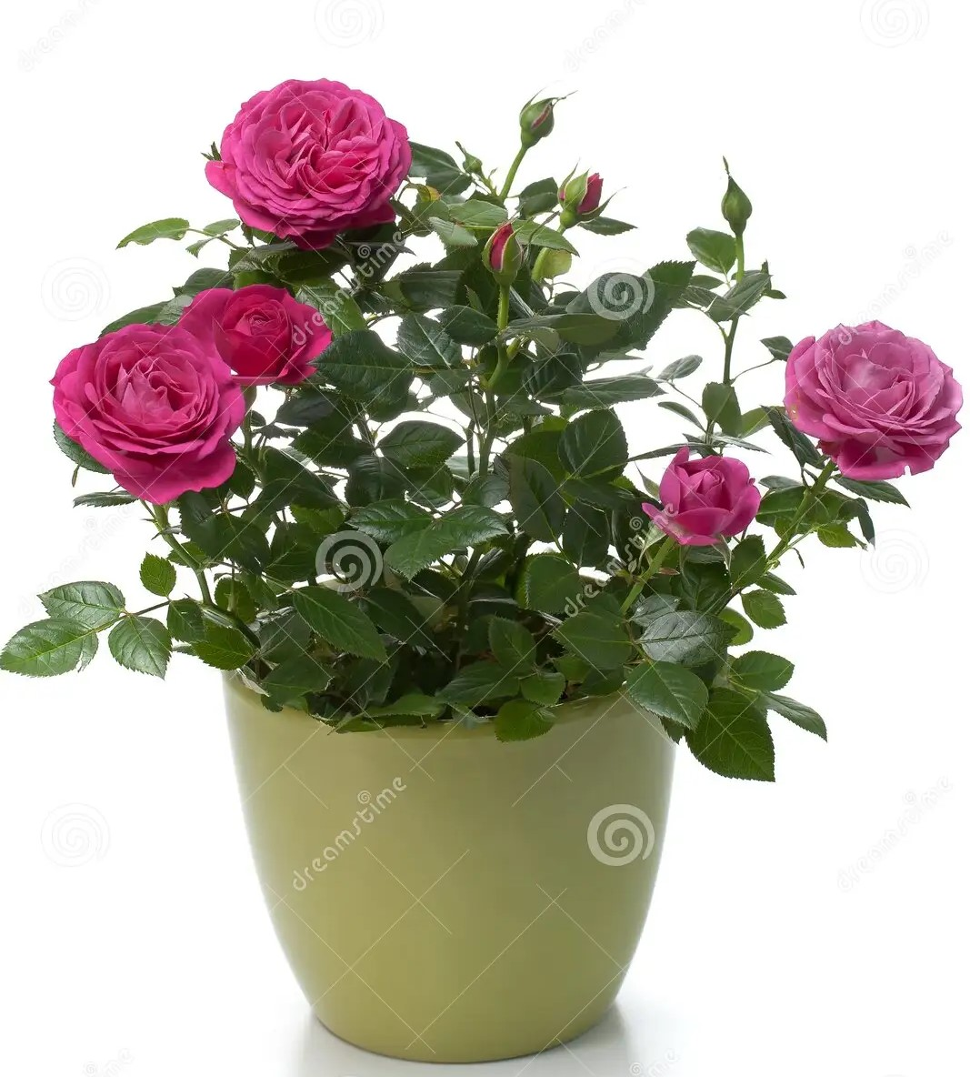**The meaning of pink roses is gratitude and admiration. They're the perfect choice for the people you appreciate most, like your friends, siblings or teachers. Pink roses can also represent femininity and elegance, which makes them perfect for events like engagement parties, proms and baby showers for a baby girl. Roses are excellent plants for growing in pots. English Roses, with their shrubby, bushy habit are ideal for growing in large pots and containers. Unlike many other potted plants, English Roses will flower in fragrant flushes throughout the summer and into the fall.It is soft pink in colour and has a nice sweet and pleasant scent to it. The flower blooms in clusters every year in June or early spring.**

# **8.House Plant:**

**A houseplant, sometimes known as a pot plant, potted plant, or an indoor plant, is an ornamental plant that is grown indoors. As such, they are found in places like residences and offices, mainly for decorative purposes.**

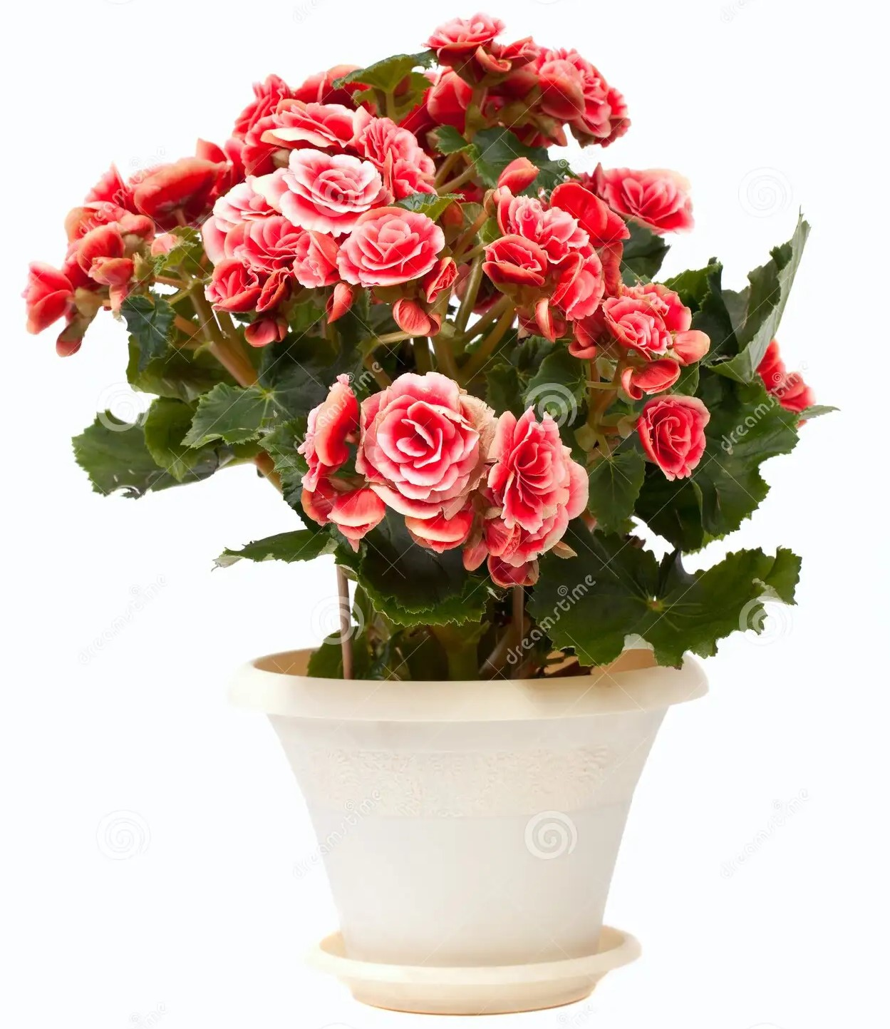

# **9.Azzaela:**

**Azaleas are loosely branched, shade-loving evergreen or deciduous shrubs with elliptical leaves. They bring delightful white, purple, yellow, and red flowers—and all hues in between—to the spring garden when the clusters of funnel-shaped blooms appear. azalea, certain species of Rhododendron of the heath family (Ericaceae), formerly placed in the genus Azalea. Many azaleas are grown as ornamentals for their showy flowers, and most of the cultivated varieties have been bred from species that are native to the hilly regions of Asia and North America.**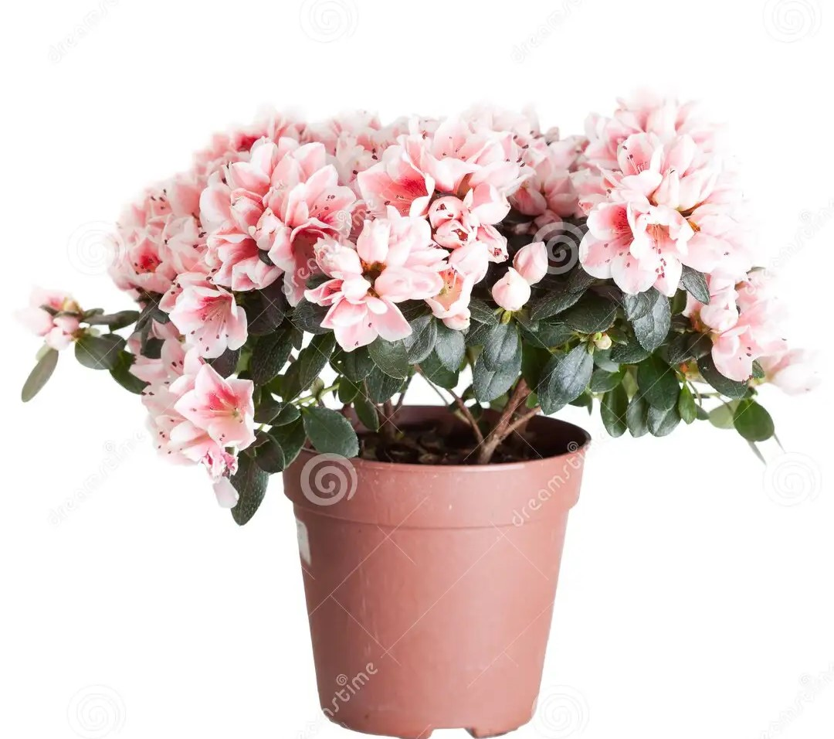

# **10.Aelovera:**

**The botanical name of Aloe vera is Aloe barbadensis miller. It belongs to Asphodelaceae (Liliaceae) family, and is a shrubby or arborescent, perennial, xerophytic, succulent, pea- green color plant. It grows mainly in the dry regions of Africa, Asia, Europe and America. Aloe vera is a popular medicinal plant with antioxidant and antibacterial properties. It may be useful for reducing dental plaque, accelerating wound healing, preventing wrinkles, and managing blood sugar, among other benefits. The botanical name of Aloe vera is Aloe vera. It belongs to the Genus Aloe and is known by many other common names such as Indian Aloe and Burn Aloe.**

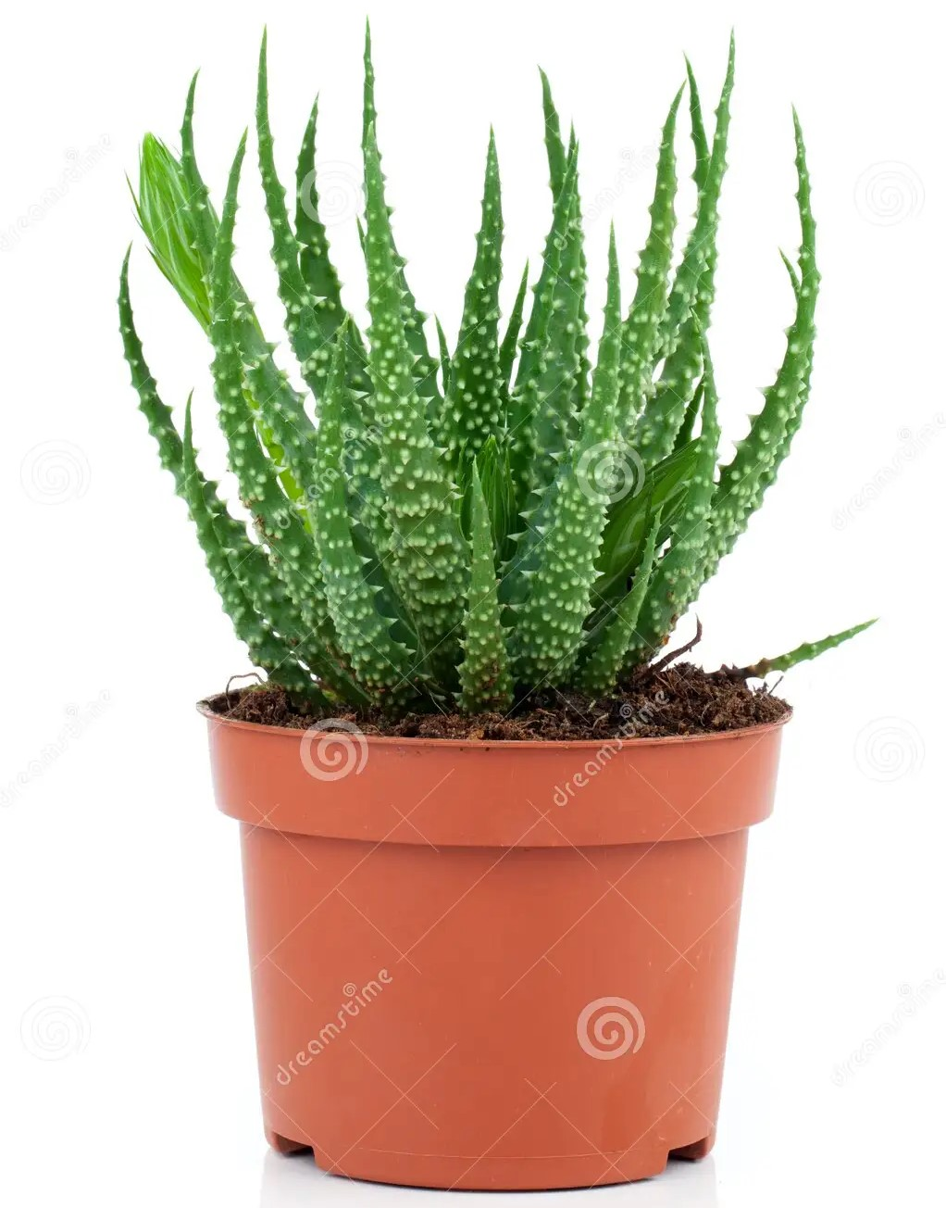

# **11.Begonia in Pulpit:**

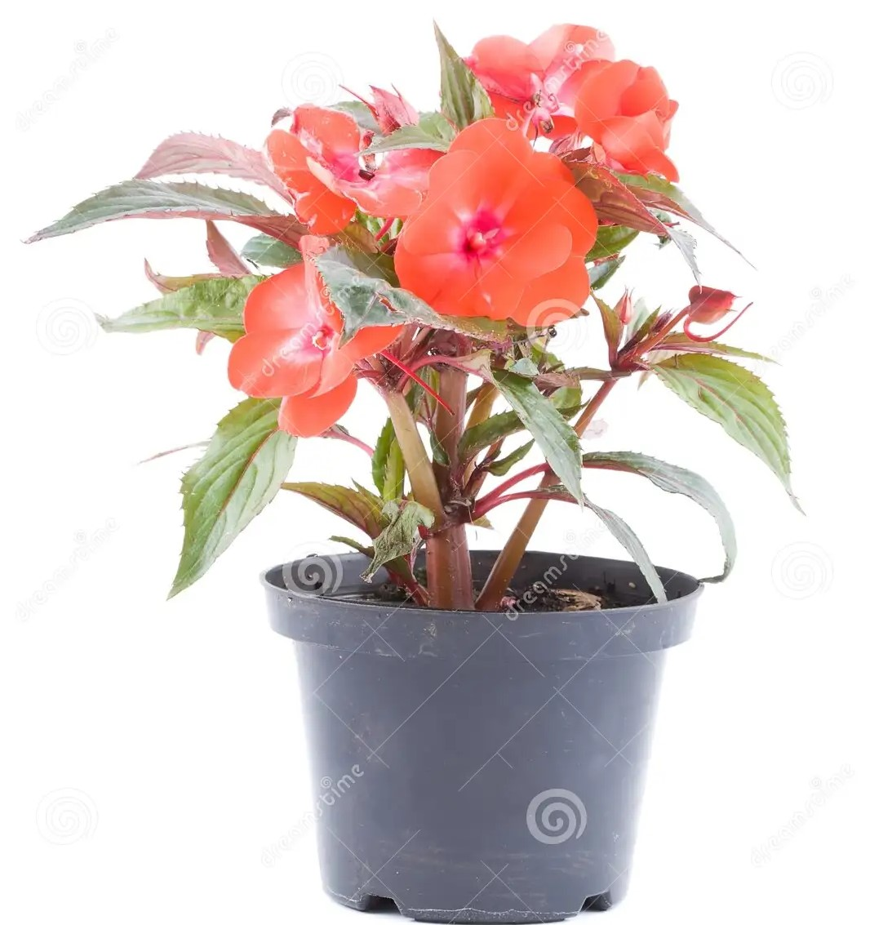**Begonia is a genus of perennial flowering plants in the family Begoniaceae. The genus contains more than 2,000 different plant species. The Begonias are native to moist subtropical and tropical climates. Some species are commonly grown indoors as ornamental houseplants in cooler climates. Begonias brighten up shady areas with their colorful blooms. Unlike most flowering plants, which require at least a half day of full sun, begonias actually prefer growing in the shade. They also never have a down time. Once begonias begin flowering, they bloom continuously from summer to frost.**

# **12.Rubber Plant:**

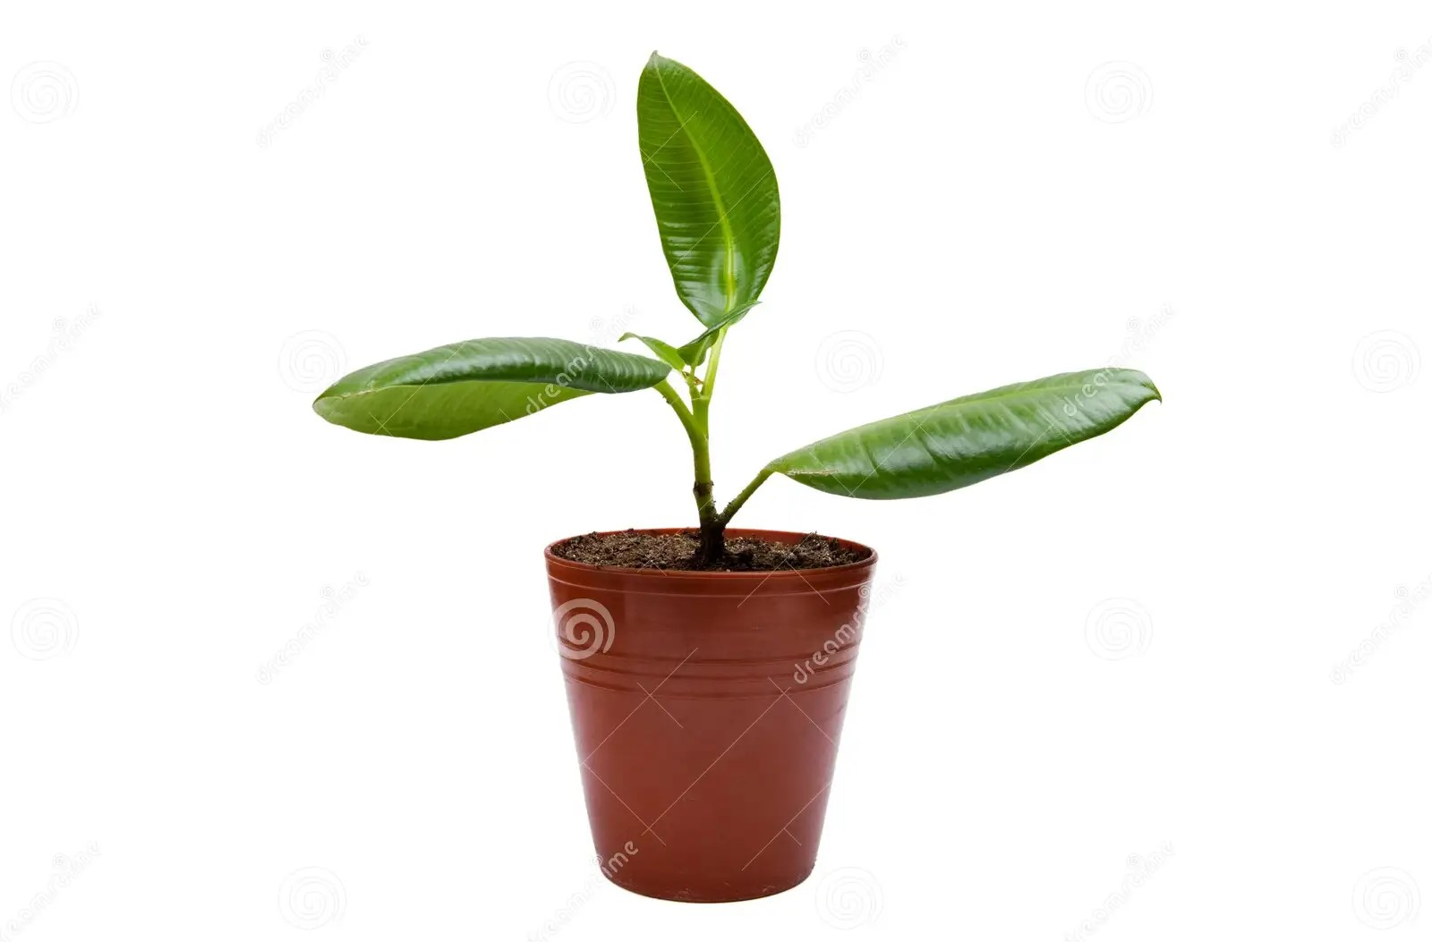**The rubber tree (Hevea brasiliensis) is a fast growing, medium to tall tree (25 m high in plantations and up to 40 m in the wild), with deep tap-roots. The trunk is smooth and straight with a grayish bark. It is known for its laticiferous system from which latex is extracted by tapping the trunk. In the wild, the rubber tree will grow to heights of 100 to 130 feet, and can live up to 100 years. Its most famous feature is the milky white sap, known as latex, which flows freely from the tree when a sliver of bark is removed.**